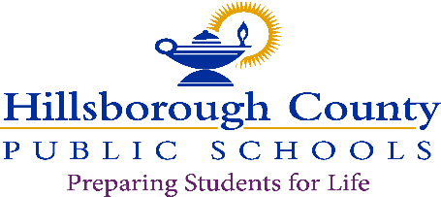

**School Board**Lynn L. Gray, ChairStacy A. Hahn, Ph.D., Vice ChairNadia T. CombsKaren PerezMelissa SnivelyJessica VaughnHenry “Shake” Washington

**Superintendent of Schools**Addison G. Davis

To Parents/Guardians:

Florida Class Size, Amendment B:

The Florida Constitution currently limits the maximum number of student assigned to each teacher in public school classrooms in the following grade groupings: for prekindergarten through grades 3, 18 students; for grades 4 through 8, 22 students: and for grades 9-12, 25 students. Under the amendment, the current limits on the maximum number of students assigned to each teacher in public school classrooms would become limits on the average number of students assigned per class to each teacher, by specified grade grouping, in each public school.

This amendment is strictly enforced at Blake High School, as well as all other Hillsborough County Public School. We will do everything we can to offer your child 7 classes throughout the regular school day. However, some Academic core classes have reached the maximum limit, if this is the case with any classes, your student may have to take a virtual class online. We will offer internet accessibility on campus to ensure that your child will have equal opportunity in completing high school classes.

Please understand that we will discuss these options during registration if your child is impacted by the state’s class size reduction law.

Parent Signature: Please Sign Digitally

Date: 2 June, 2022

Student Signature: Please Sign Digitally

Date: 2 June, 2022